**Lab 2 Docker Setup**

Now that you are familiar with Docker, it’s time to install it on your Windows computer.

**Once you have docker installed just run the command “docker info” in command line and take a screenshot with your desktop in the background as well.**

1. Enable Hyper-V
   1. Press your windows button (or click in the search box on the meu) and search for “turn Windows features on and off”. )
   2. Click on the Hyper-V box to enable it.

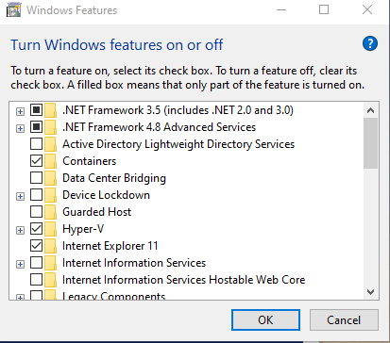

1. Docker Hub
   1. Go to hub.docker.com
   2. Sign up

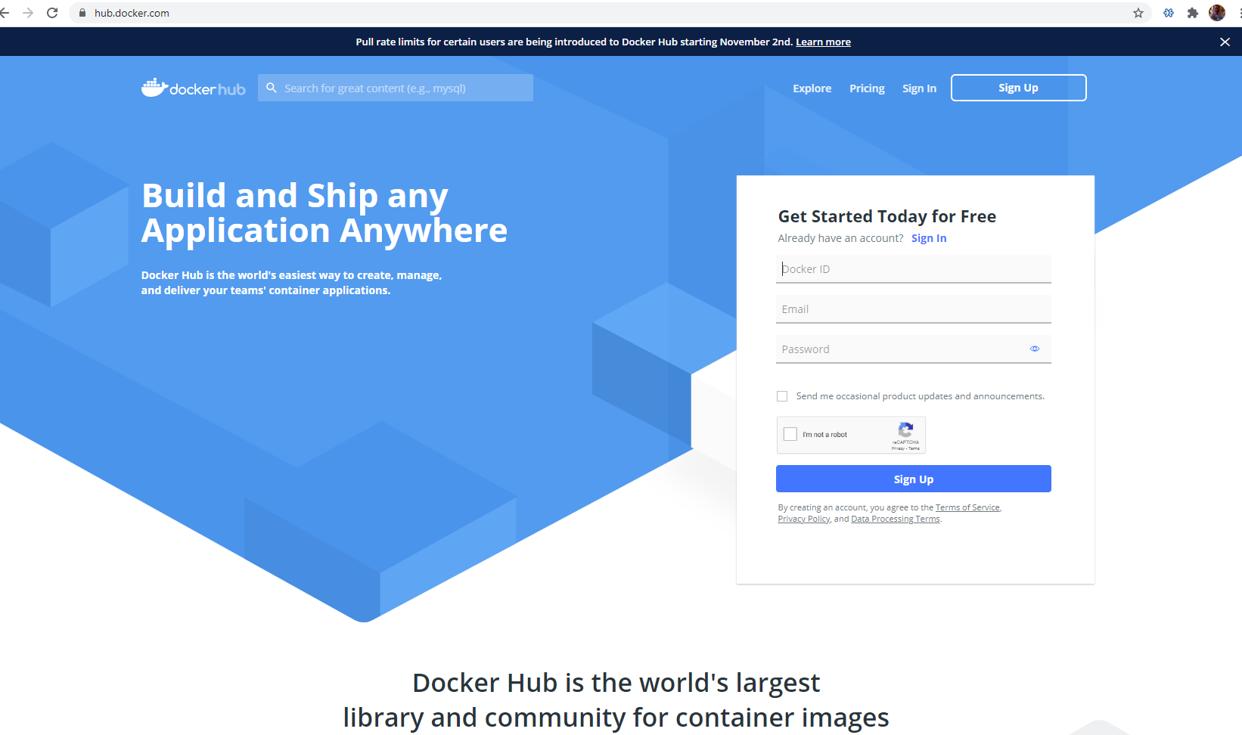

1. Download Docker
   1. Click on the tab to download docker
   2. Install the .exe file
   3. Updates
      1. You will probably get a message to install the MSI update package
         1. Go ahead and install this
      2. Lastly you will most likely need to enable virtualization within your BIOS
         1. Restart your computer and push F10 while it is rebooting
         2. You will want to look around in your BIOS to find where to enable “VIRTUALIZATION”
            1. You may need to go to Advanced settings on the BIOS menu
            2. Then you may need to go into another list for system configuration
            3. Enable the virtualization and then save and exit the BIOS

(you will probably have to restart the computer again after making this change)

1. Docker Desktop
   1. Now when you turn on the computer it should start up docker and virtualization
   2. Click on the Docker Desktop icon
   3. Now you are in an app to help you interact with Docker
      1. A command line, windows power shell, will show up on the right side of the app (if the command line doesn’t show up you will need to go into the search tab in windows and type ‘cmd’.)

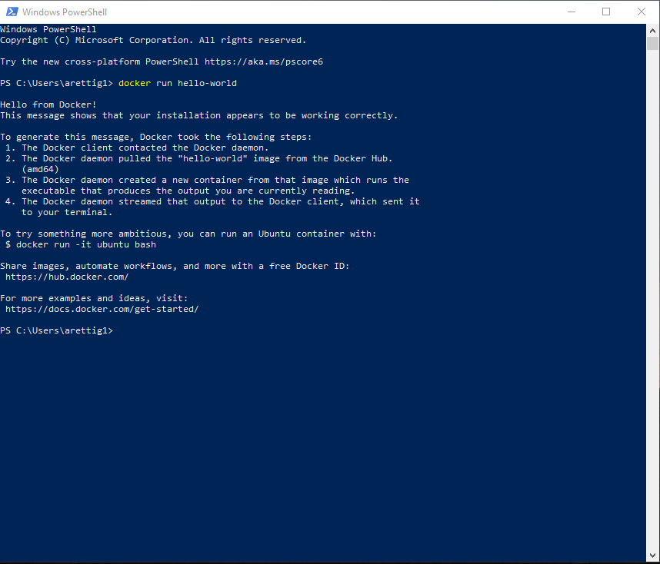

* + 1. We can use the command line to easily interact with docker as well as clicking around the app
    2. Enter the following command in the power shell or cmd “docker run hello-world”
       1. If everything is installed correctly, this command will run your first container with no errors
    3. Now look in the app to find the image it downloaded for hello-world and the container it created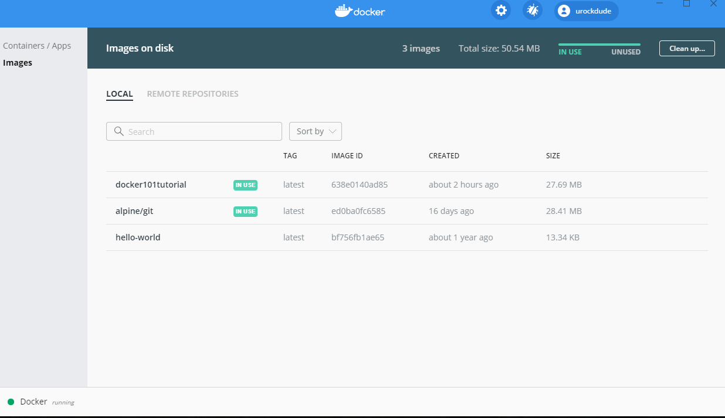

1. Docker Tutorial
   1. Now you can go ahead and do the tutorial if you want. (this part is optional)
   2. Do steps 1-3 to setup a webserver locally with a tutorial
      1. Step 4 is for uploading and can be skipped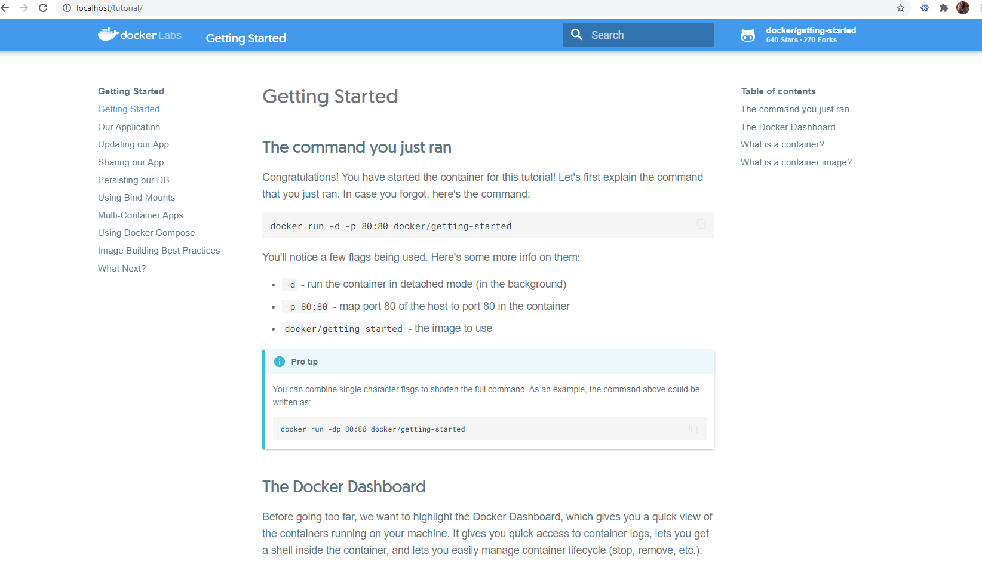
2. **Once you have docker installed just run the command “docker info” in command line and take a screenshot with your desktop in the background as well.**

Additional Information: <https://docs.docker.com/docker-for-windows/>

Alternate Instructions: <https://hub.docker.com/editions/community/docker-ce-desktop-windows>